**Tips For Using Playposit/Troubleshooting Guide**

**Best Fixes will be in bold**

**The best browser for using Playposit is google chrome. If you are having issues, download it. It is free!**

**If it is still not working even though you are using google chrome, try updating to the latest version of google chrome.**

Still having problems??

**Try clearing your cache**

**Outlined below are the shortcuts to clear your cache.  
  
  
Chrome (for Mac or Windows) - Cmd+Shift+Delete | Ctrl+Shift+Delete  
  
Firefox (for Mac or Windows) - Cmd+Shift+Delete | Ctrl+Shift+Delete  
  
Internet Explorer - Ctrl+Shift+Delete  
  
Safari (for Mac) - Cmd+Option+E**

Cookies on Playposit

Please make sure to enable third party cookies in your web browser for the most fully-featured experience.

Enable third-party cookies in:

Google Chrome:

**Enable Cookies in Chrome**

1. Click the "Customize and Control" button. ...
2. Select the "Settings" menu item. ...
3. Search for the **Cookies** settings. ...
4. Scroll down to "Site settings" and click it. ...
5. Click the "**Cookies**" item. ...
6. Choose your preferred **Cookies** settings. ...
7. Close the settings tab.

OR

1. **Click on Chrome on the top left hand corner**
2. **Click on preferences**
3. **Go to privacy and security**
4. **Go to cookies and site data**
5. **Make sure you do not have 3rd party cookies blocked**

 on your Mac, choose Safari > Preferences, then click Privacy.

Select “Prevent cross-site tracking.”

Unless you visit and interact with the third-party content provider as a first-party website, their [cookies and website data](https://support.apple.com/guide/safari/aside/glos0126d795/13.0/mac/10.15) are deleted.

Social media sites often put Share, Like, or Comment buttons on other websites. These buttons can be used to track your web browsing—even if you don’t use them. Safari blocks that tracking. If you still want to use the buttons, you’ll be asked for your permission to allow the site to see your activities on the other websites.

Firefox

Some websites may not work properly when third-party cookies are blocked, even with the *Cross-site and social media trackers* setting.

To turn off Enhanced Tracking Protection for a specific website:

1. Visit the website.
2. Click on the shield  to the left of the address bar.

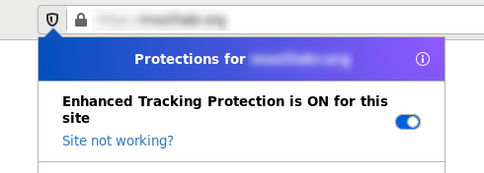

1. Toggle the switch Fx70-ETPswitch at the top of the panel.

This will turn off Enhanced Tracking Protection for this site. The page will reload automatically and allow trackers on this site only.

To turn Enhanced Tracking Protection back on, follow the same process.

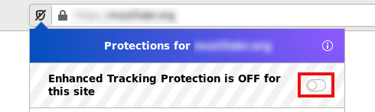

In certain cases, when trying to create or access an assignment within your Learning Management System (LMS), you may encounter an error message stating "Oops! It seems your browser is not allowing us to set cookies. Please click on the button below to continue in a new tab."

If you encounter the above error message, try the following:

* If you encounter this error message while using Chrome version 80 in incognito mode, make sure to toggle third party cookies on when first opening an incognito window. Instructions on how to do this can be found [here](https://support.google.com/chrome/answer/95647?co=GENIE.Platform%3DDesktop&hl=en).
* If you are still experiencing issues on Chrome version 80 or above, please contact help@playposit.org